Q1:

As mentioned in the DataCamp course, in chapter 4, on exercise “K-means: Average silhouette Widths”, 3 was the correct answer for k. how did we understand whether 7 groups are overfitted?

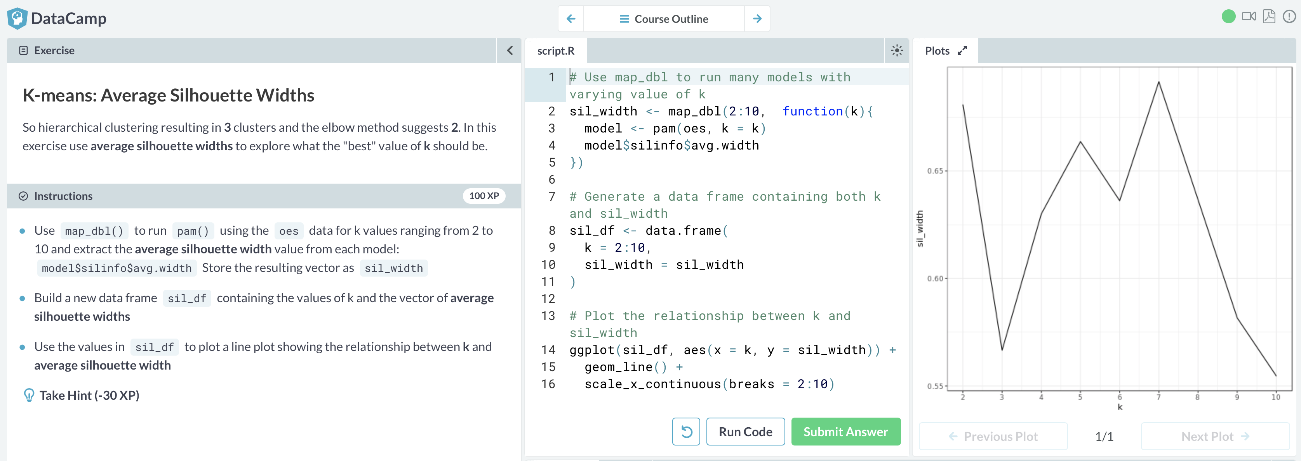

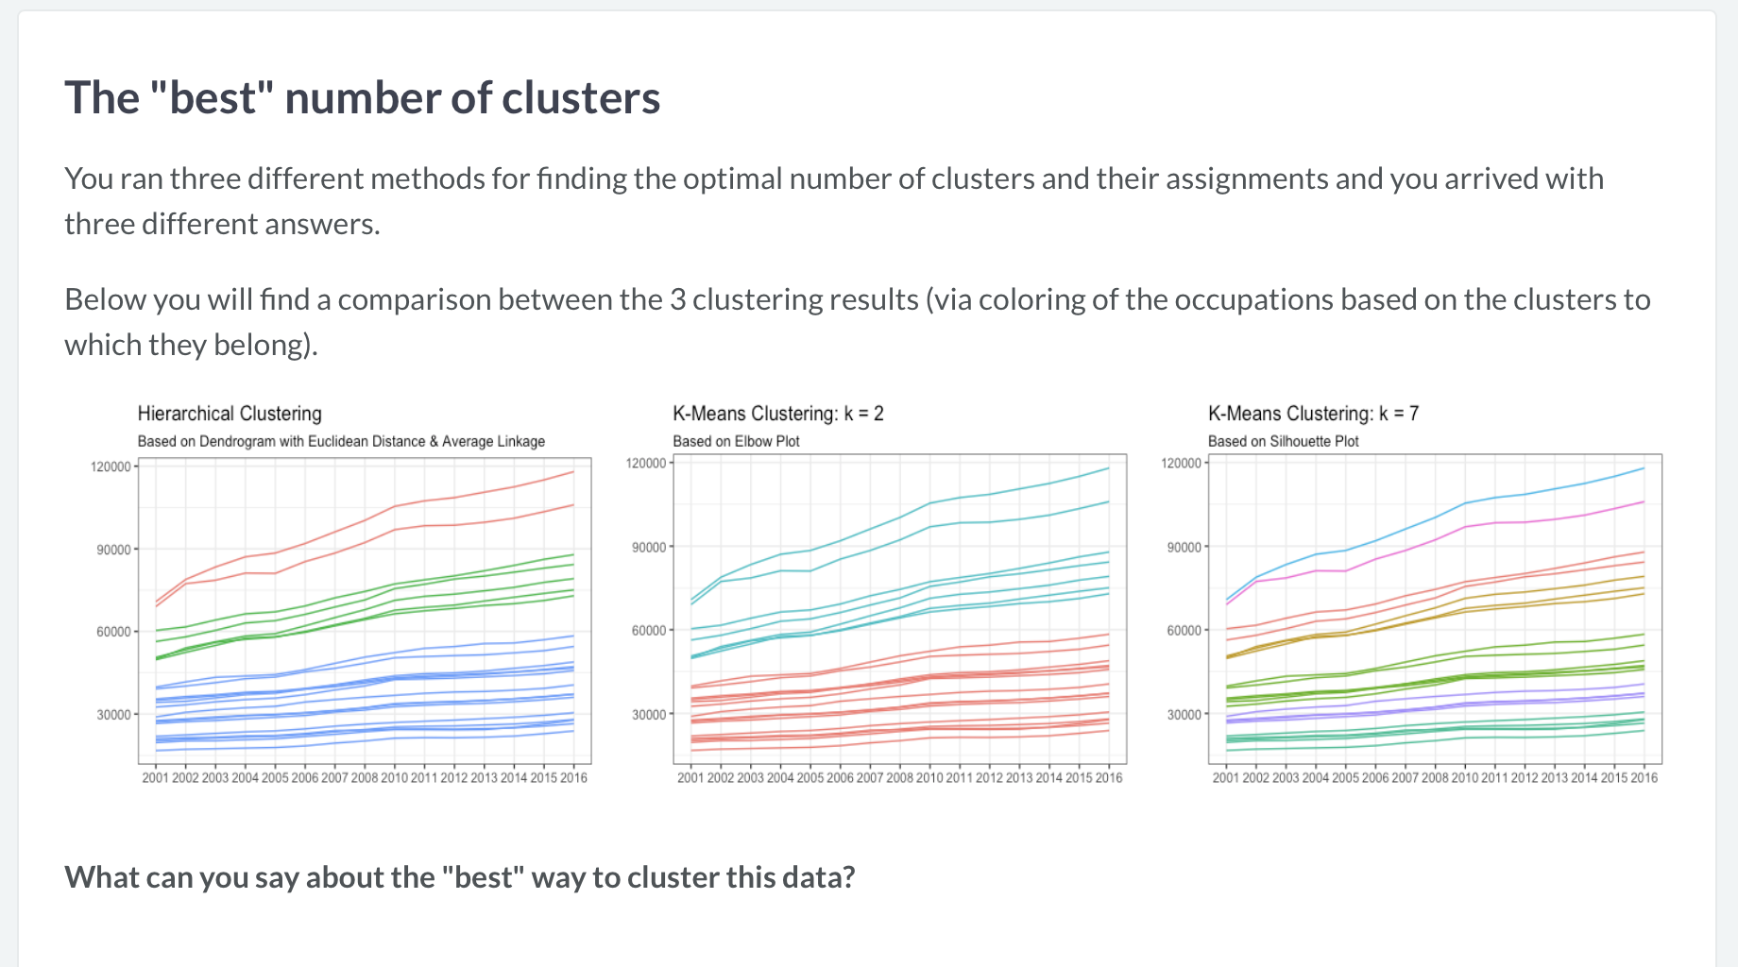

Q2:

R for Marketing Research and Analytics:

In “Examining Similarities” section from Chapter 11, it is mentioned that we can cut the tree at a particular height and plot above or below. The plot is cut at a height of 0.5. Is there any importance to this particular height?

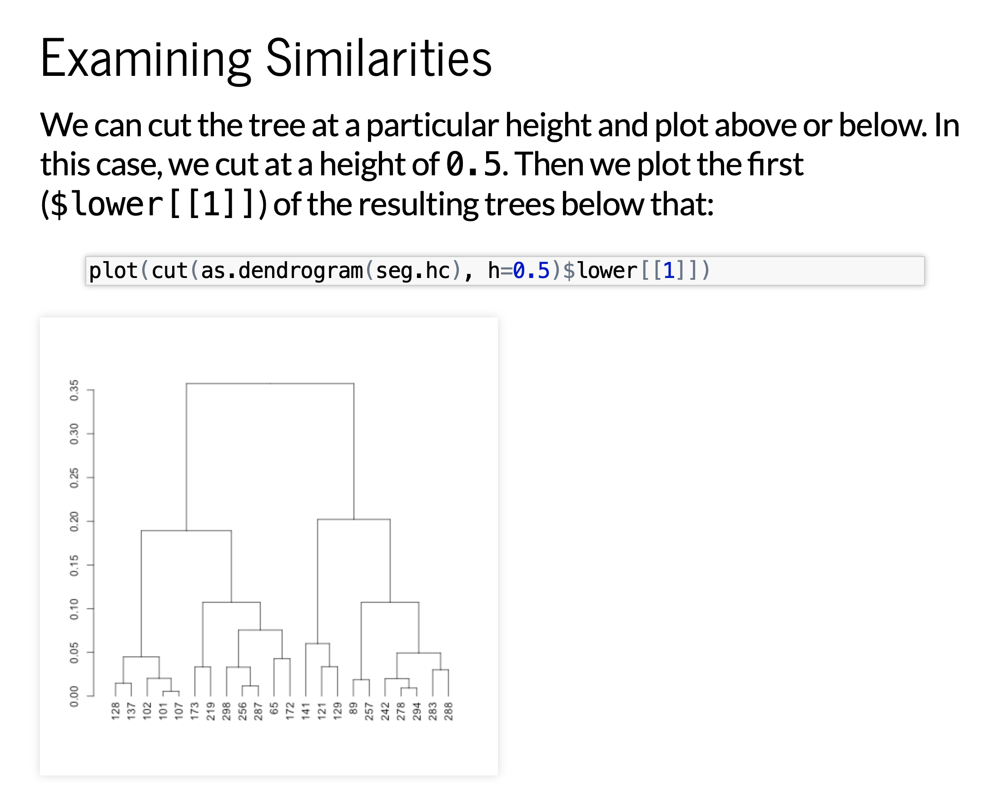

Q3:

R for Marketing Research and Analytics:

In “Heatmap for variable importance” section from Chapter 11, according to the heatmap shown, gender seems not be distinctive between segments. Can we extract it from the model?

